GrassMarlin Exercise
Industrial Control Systems Cybersecurity (300) Training
4. Select “File → Import Files” from the top menu and the following screen will appear.
5. Click the Add button and select /pigpen/Desktop/pcap_files/ExploitDemo/ExploitDemo.pcap.
After the file is added, the Import Selected button will be active. Click it to import the file. After the file is imported, close the import window. You will see a network diagram in the “Logical Graph Tab” of the right window.
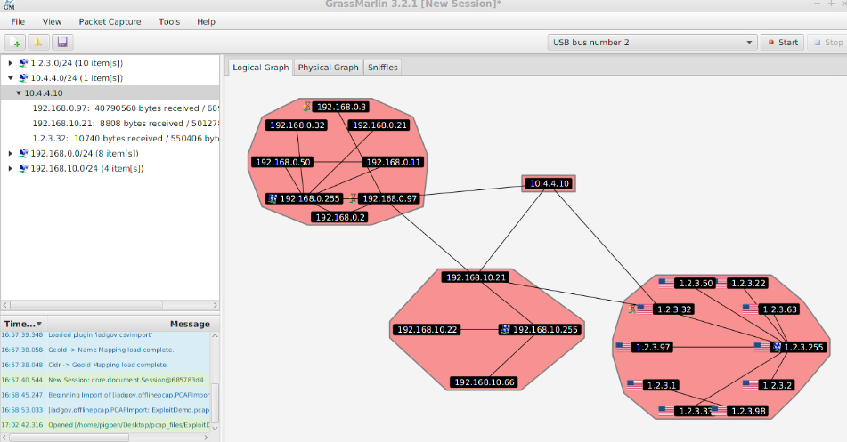
a. You can see 10.4.4.10 is an outside IP address communicating directly to computers inside the corporate (1.2.3.0/24), DMZ (192.168.10.0/24), and PCS (192.168.0.0/24) networks. In the left side top window expand the 10.4.4.0/24 network by clicking the triangle in front of the network range. Now expand the 10.4.4.10 entry. You can see the connections and bytes sent and received. Right-click on 10.4.4.10 and select “View Frames” from the menu. Write down the IP addresses that have a direct connection with the attacker in the order of the attacker access. (Note: Right clicking on any of the individual connections and selecting
Wireshark will allow you to view the packet.)
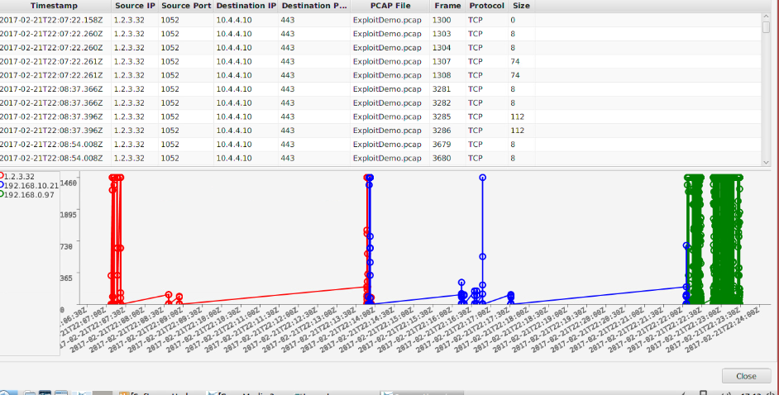
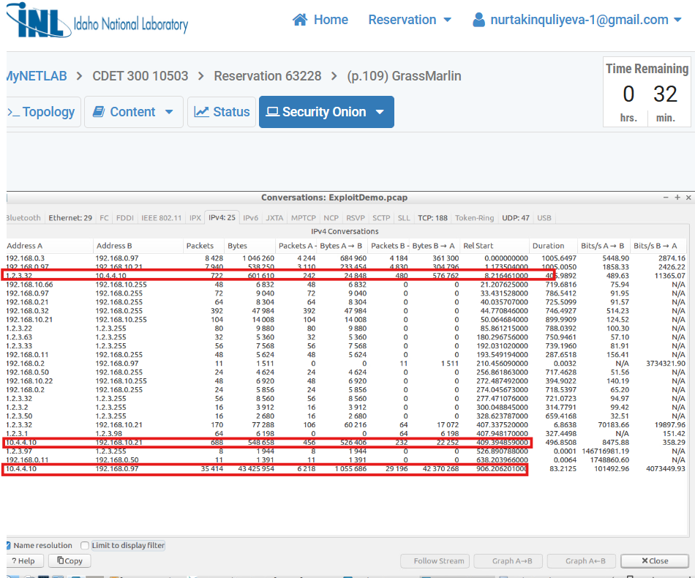
a.Wireshark Analysis - Actions Taken

1. The PCAP file was opened in Wireshark.
2. The attacker IP was identified: 10.4.4.10.
3. A filter was applied: ip.addr == 10.4.4.10 - showing only traffic related to the
attacker.
4. Source and Destination columns were analyzed to identify which IPs have direct
connections with the attacker.
5. Packets were sorted by the Time/Timestamp column in ascending order.
. This was done to determine the chronological order of connections.
6. The Statistics - Conversations - IPv4 section was checked:
. All IPs communicating with 10.4.4.10 were grouped.
. Packets count, Bytes, and Start Time columns were used to verify the connection
order.
7. Access sequence was determined:
1. 1.2.3.32
2. 192.168.10.21
3. 192.168.0.97
8. Broadcast IPs (.255) were ignored as they are not direct attacker connections.
9. Attack behavior was observed:
9.1 Lateral movement was observed: Corporate - DMZ - PCS networks.

The attacker (10.4.4.10) established direct connections with three hosts and moved
laterally across different networks in sequence. The analysis involved filtering packets by
attacker IP, sorting by timestamp to determine the order of connections, and using the
Conversations view to efficiently identify direct connections.

b. In the logical graph tab, the icon in front of 192.168.0.97 indicates it is a control system machine. Right-click on its IP address in the diagram and select View Details to learn more 111 | PageIndustrial Control Systems Cybersecurity (300) Training
112 | Page about the computer. You may need to expand the pop-up window. What type ICS protocol is used by 192.168.0.97?
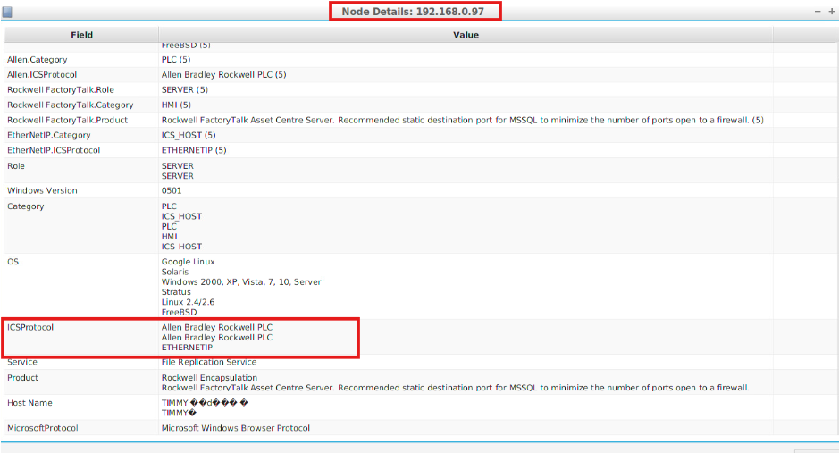
b. ICS Node Analysis
Node: 192.168.0.97
Context: In the logical graph tab, this node is marked as a control system machine. The task involved right-
clicking on the IP address in the diagram, selecting View Details, and reviewing the pop-up window to
identify the type of ICS protocol used.

Analysis Steps:
1. Accessed View Details for 192.168.0.97 in the logical graph tab.
2. Expanded the pop-up window to see all available node attributes.
3. Examined relevant fields for Industrial Control System (ICS) protocols:
. Allen.ICSProtocol: PLC communication protocol
. EtherNetIP.ICSProtocol: ETHERNET/IP
. Rockwell FactoryTalk: Asset Centre Server (HMI/SCADA application)

Results:
. ICS Protocol used: EtherNet/IP
. Device Role: PLC / ICS Host
. Related Software: Rockwell FactoryTalk Asset Centre Server
. OS/Service Info: Windows-based host (supports Windows 2000-10 / Server editions)
. Notes: The recommended static destination port for MSSQL is suggested to reduce firewall exposure.
The node serves as a critical ICS host connecting PLCs and HMI services.
The node 192.168.0.97 is a control system machine using EtherNet/IP as its primary ICS protocol. It functions
as an ICS host within the network, managing PLCs and HMI applications via Rockwell FactoryTalk. This
information is critical for network defense, ICS monitoring, and incident response planning.

c. Select “View → Logical Nodes Report” from the menu. Click the down arrow
and a list of columns you can add to the logical node report will be displayed. Select the “Rockwell Factory Talk.Category” list item. Now select “Add” or “…” depending on your window size. What IP has information for this column and what information was provided?
(NOTE: Once you have finished building a report, you can export to a CSV file using the button provided.)
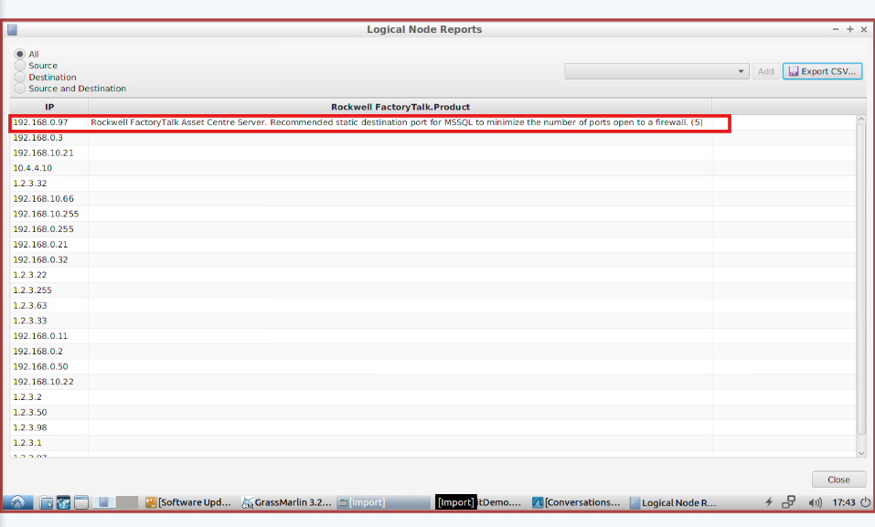
c. Logical Nodes Report
To explore the networked devices in your system, understand what Rockwell products are running on which IPs, and collect this information in a report.
Steps Taken:
1. Selected View - Logical Nodes Report from the menu.
2. Clicked the down arrow to see the list of available columns.
3. Added the column "Rockwell FactoryTalk.Category" (or Product column) to the report.
4. Checked which IP addresses had information for this column and what the information was.
5. Exported the report to CSV for further analysis.:
IP 192.168.0.97 hosts FactoryTalk Asset Centre Server.
The report also includes a recommendation: use a static destination port for MSSQL to minimize
firewall exposure, enhancing security.This report allows you to monitor devices, perform diagnostics, understand device roles, and maintain a documented asset inventory.
Helps track which devices are running which Rockwell software. Supports troubleshooting if devices or categories fail to report data.Useful for system security, inventory, and management documentation.

2. Recommendation Analysis
. The message about static MSSQL ports is advisory. It is not just information; it suggests optimizing
system security and performance.
. Applying the recommendation ensures:
1. Fewer open ports on the firewall.
2. Improved network security.
3. Better system stability and predictable device behavior.

d. Select “View → Logical Connections Report” from the menu. How could this information be used in getting to know your network? Or building an Asset Inventory?
NOTE: This provides another way to export your information to a CSV file to be used by other
tools.
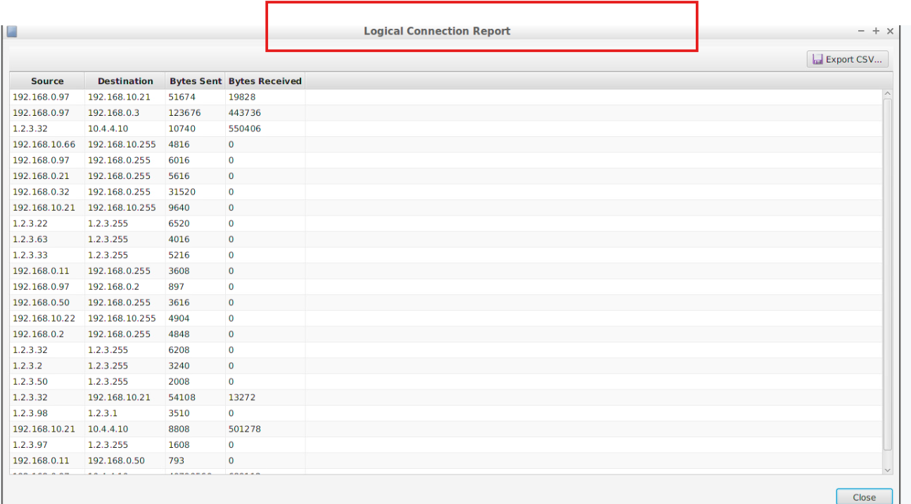

d. Logical Connections Report
To understand how devices are communicating with each other on the network and to build an Asset
Inventory.
1. Selected View - Logical Connections Report from the menu.
2. Chose relevant columns: Source IP, Destination IP, Bytes Sent, Bytes Received.
3. Added them to the report and exported to CSV.
. 192.168.0.97 is a highly active device communicating with multiple destinations.
. The "Bytes Sent" and "Bytes Received" columns indicate the volume of data exchanged.
. This information shows:
. Active network devices
. Traffic patterns
. Potential bottlenecks or unusually high traffic that may need investigation

